
ATAR Biology

Unit 2: Topic 1
Week 20 – Cell Organelles

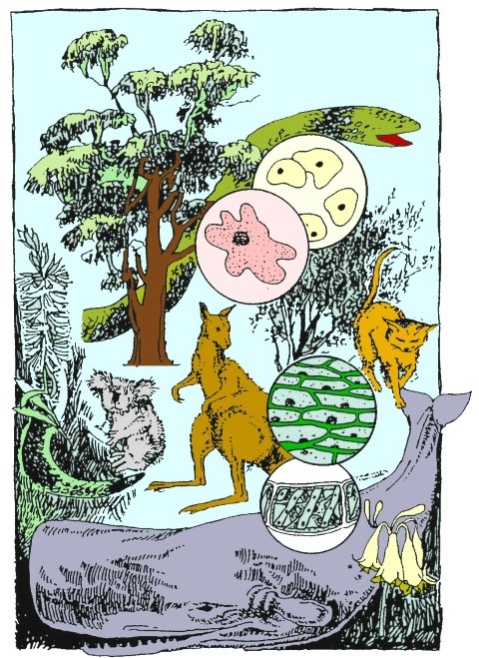
© SIDE

Student Study Notes

Unit Content
- Eukaryotic cells carry out specific cellular functions in specialised structures and organelles, including:
  - cell membrane
  - cell wall
  - chloroplasts
  - endoplasmic reticulum (rough and smooth)
  - Golgi apparatus
  - lysosomes
  - mitochondria
  - nucleus
  - ribosomes
  - vacuoles
- The cell membrane model has been continually reconceptualised and revised since the mid-nineteenth century and the currently accepted model, based on the evidence from improved technologies, is the fluid mosaic model.

Parts of the cell

Most cells have certain structures in common. A typical cell consists of a cell (or plasma) membrane, cytoplasm, nucleus and other structures. In addition, plant cells have a rigid cell wall and chloroplasts.
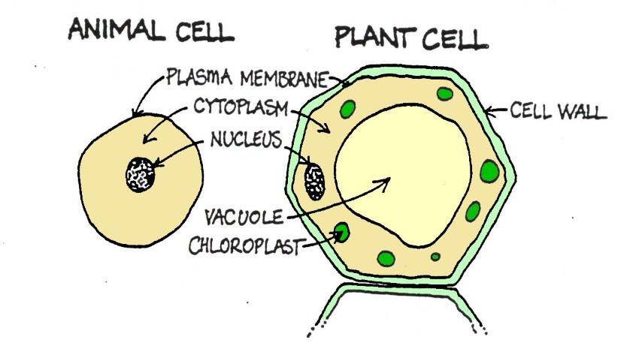
© SIDE

Cell organelles
The development of the electron microscope in the 1930s provided more detailed knowledge of cell structure and function. In particular, specialised structures within the cytoplasm of eukaryotic cells were revealed. Most of these structures have their own membrane and are known as ‘little organs’ or organelles.
Cell organelles include:
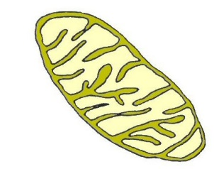
- cell membrane
- cell wall
- chloroplasts
- endoplasmic reticulum (rough and smooth)
- Golgi apparatus
- lysosomes
- mitochondria
- nucleus
- ribosomes
- vacuoles
Each organelle has a particular function which is usually related to its structure. Some of the organelles listed above are shown in the diagram below.
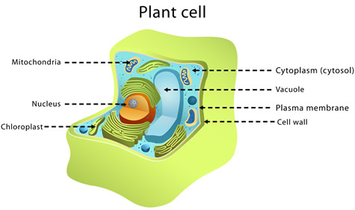
© WestOne

Cell membrane – The boundary
The cell membrane, or plasma membrane, is a thin layer that encloses the cell and acts as a boundary between the cell and its environment. The cell membrane controls the transport of materials into and out of the cell. Only certain substances are allowed passage which makes the cell (or plasma) membrane selective or semipermeable.

Cytoplasm – The cell contents
Cytoplasm is the jelly-like material within a cell, containing cytosol and cell organelles. Cytosol consists mostly of water but also contains many dissolved substances.

Nucleus
The nucleus controls the chemical activities of the cell. The double membrane surrounding the nucleus has pores which allow the passage of materials in and out of the nucleus. The area within the nucleus, called the nucleoplasm, contains the hereditary material, known as DNA, essential for controlling cellular activities, reproduction and passing on inheritable characteristics from parents to offspring.

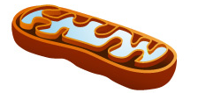
Mitochondria – The cell energy supplier
Mitochondria appear as rod-shaped or sausage-shaped structures that contain a folded inner membrane. Several of these organelles may be present in one cell and they are all surrounded by a double membrane. The function of mitochondria is to provide energy for the living cell to use through cellular respiration.

With cellular respiration, glucose combines with oxygen to release energy that the cell can use. During this process, carbon dioxide and water are produced as waste products. The word equation for this process is shown below:
glucose + oxygen → energy + carbon dioxide + water
A continuous supply of glucose and oxygen to the cell is essential for this process and the survival of the cell.
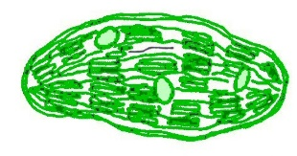

Chloroplasts – The solar panels for life
Chloroplasts are membrane-bound organelles which contain the green pigment, chlorophyll. There can be many chloroplasts in one plant cell. The function of chloroplasts is photosynthesis.
© SIDE

Vacuoles – The cell store
These are membrane-bound fluid filled 'spaces' in the cytoplasm. The main function of vacuoles is the storage of substances, especially water. In animal cells, if present, vacuoles tend to be small. In plant cells, they are usually large and help maintain the shape of the cell.

Cell wall
A rigid cell wall surrounds the cell (or plasma) membrane in Monera, Fungi, Plants and Protista such as alga. Cell walls are absent in animal and some Protista. In plants, the function of the cell wall is to give shape and support to the cell and allow the rapid movement of water from cell to cell.

Comparing plant and animal cells
The diagram below shows a typical plant and animal cell when viewed under the light microscope with only the plant cell possessing a cell wall, chloroplasts and a large fluid ﬁlled vacuole.
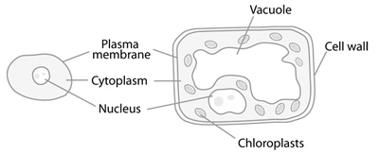
Which important energy providing organelle, found in both plant and animal cells, is not shown in the diagram?

As you can see in the diagram, there are structural and functional differences between plant cells and animal cells.

Some of these differences are listed in the table below.

Animal cell | Plant cell
Unable to photosynthesise | Able to photosynthesise
Flexible cell membranes, no cell wall | Rigid cell wall surrounds cell membrane
No chloroplasts | Many chloroplasts
Lack large vacuoles | Large ﬂuid filled vacuoles
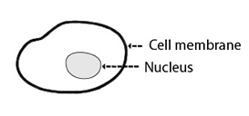 | 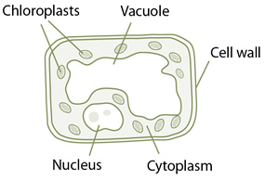

PRACTICE QUESTIONS:
Use your lesson notes, textbook and additional research to answer the questions below.

1. Complete the table below

Cell organelle | Function
 | An insoluble boundary of a cell which regulates the movement of substances into and out of the cell.
 | A double membrane with pores which controls cell activities.
 | fluid-filled space that stores materials
 | rigid outer cover for protection and support in plant cells
 | main function is photosynthesis
endoplasmic reticulum

Golgi apparatus

lysosomes

Ribosomes

vacuoles

2. a) Label the mitochondria, chloroplast and nucleus on the diagrams below.
b) Label the cells as a plant or an animal cell.

A ________________ B________________

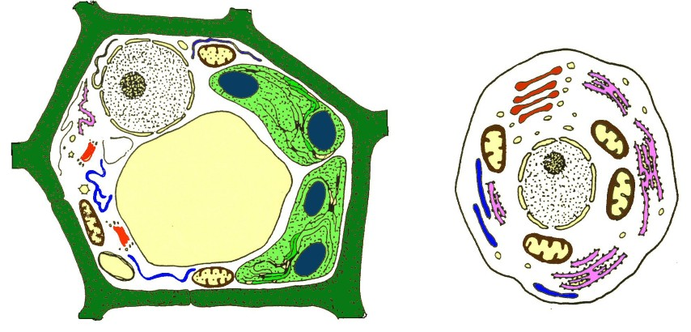
© SIDE

3. Some organelles are found in both plant and animal cells but may have slightly different functions. For example, plant cells contain large fluid filled vacuoles. The water in these vacuoles maintains the shape of the cell and physically supports the young plant as it grows. Vacuoles in animal cells are usually small or absent and may be used to store waste.

Complete the table below by identifying the organelles usually found in both plant and animal cells.

Cell organelle | Function
 | supplies energy/cellular respiration
 | controls cell activities
 | contains dissolved substances for cell use
 | transports materials in and out of cell

4. There is really no such thing as a typical plant or animal cell as most cells are specialised for a particular function. An example of a specialised cell is the red blood cell.

a. What is the function of a red blood cell?

b. What structure is missing from a mature red blood cell?

c. Name a specialised plant cell and suggest its function.

5. Identify the set of structures that are present in both plant AND animal cells.
- mitochondria, nucleolus, cell membrane, Golgi apparatus
- cytoplasm, cell wall, nucleus, mitochondria
- cell membrane, cell wall, Golgi apparatus, nucleus
- chloroplast, mitochondria, endoplasmic reticulum, cell membrane.

6. Which of the following is NOT a function of the cell membrane.
- Controls entry and exit of cell materials
- Enclosed cell contents
- Site of protein synthesis
- Has a role in endocytosis and exocytosis

7. Student 1 examined four cell types from four different living organisms under a microscope. She placed a mark (+) in the table below when she was certain that a structure was present and a dash (-) if she was certain it was absent.

 | Cells
Cell components | I | II | III | IV
nucleus | + | - | + | +
cell wall | - | + | - | -
plasma membrane | + | + | + | +
cytoplasm | + | - | + | +
vacuole | - | - | - | +
chloroplast | - | + | - | -
mitochondrion | - | - | - | -

(a) From these observations she concluded that cell I must be eukaryotic.

(i) Is this conclusion true or false? Give a reason for your answer. (2 marks)

(ii) Student 2 looked at the table and suggested that there must be a mistake in the entries for cell II. What is the mistake and how do you know it is a mistake?
(2 marks)

(b) From the observations in the table Student 1 also made the following conclusions about which cells were from animals and which cells were from plants. Indicate whether, on the basis of the data in the table, you believe her conclusions are true or false and give
one (1) reason for your decision in each case.

(i) cell III must be from an animal (2 marks)

(ii) cell IV must be prokaryotic (2 marks)

(c) Briefly describe one (1) function of each of the following cell components.

(i) nucleus (2 marks)

(ii) chloroplast (2 marks)

